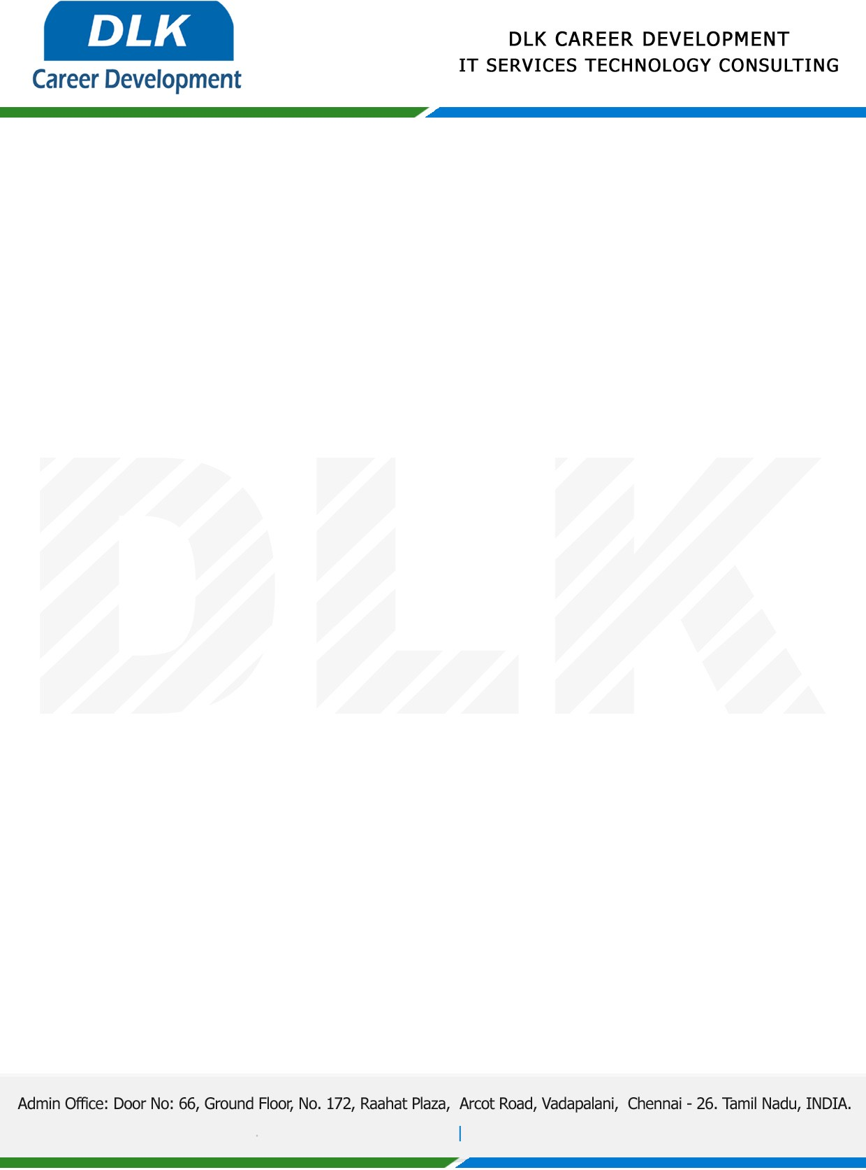

**Date: 12/ March /2023**

**SUB: PROJECT COMPLETION CERTIFICATE**

This is to certify that **MS JANUSHREE N (REG NO:** **212002625) BCA- Computer Application,** final year student **Dr.MGR Janaki College of Arts and Science, Chennai** has Successfully Completed the Project Work under the domain of “**Java”** in our organization during the Period **(06th March 2023** to **11th March 2023).**

**Topic:** Online Medical Consultation System**.**

We appreciate your interest in **DLK CAREER DEVELOPMENT**

**“Best Wishes for Your Future Endeavors “**

